PRODUCT INFORMATION
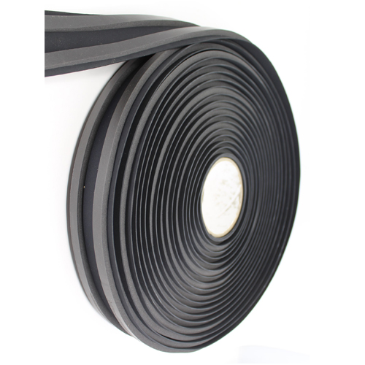
PBUT Butyl Rubber Strip

Product Description:
PBUT is an Elastomeric Rubber Roofing and Waterproofing Membrane (Manufactured from an EPDM Butyl Rubber Polymer Blend). It is a copolymer of isobutylene with small amounts of isoprene, two gases derived from petroleum distillation. The butyl rubber molecule has a highly saturated structure, and therefore is resistant to heat ageing processes, sunlight and ozone and has exceptionally high resistance to diffusion by gases and liquids (other than mineral oils and solvents). Butyl was commercialised in 1937, it is also used in tyre inner tubes because of its resistance to gas diffusion.
EPDM is an inert polymer made by co-polymerising Ethylene and Propylene with small amounts of another polymer. Its excellent weathering properties provide PBUT with increased durability compared to pure Butyl membranes.

Product Data:
Colour: Standard colour is black
Dimensions: 50mm x 12m
80mm x 12m
Service Temperature Range: -50°C to 110°C
Life Expectancy: Tropical Areas - In excess of 20 Years
Temperature Zones – Earliest application still good after
40 years

Applications:
- Industrial, commercial and residential flat roofs and gutters.
- Irregular angles, curves and contours of any scale architecture.

Physical Property | Test Method | Spec. | Typical
Hardness, Shore A | ASTM D 2240 | 68 +/ -5 | Pass
Tensile Strength, MPa | ASTM D 412 | 8.3 Min | 9.2
Elongation, Ultimate % | ASTM D 412 | 300 Min | 441
Resistance to Heat Ageing  Properties after 166 Hours @ 116°C (240°)  Tensile Strength, psi (MPa)  Elongation, Ultimate % | ASTM D 573  ASTM D 412  ASTM D 412 | 6.2 Min  210 Min | 8.6  311
Ozone Resistance  Condition after exposure to 50 pphm  Ozone in air for 7 days @ 40°C  Specimen is at 25% strain | ASTM D 1149 | No Cracks | No Cracks
Water Vapour Permeance  At 23°C ± 2°C, 45% Rh, perms | ASTM E 96 | 0.06 Max | 0.02
Resistance to Water Absorption  After 166 hours in immersion @ 70°C  Change in mass % | ASTM D 471 | 4 Max | 3.2
Specific Gravity, typical |  |  | 1.2 Black  1.3 Colour
Thermal Conductivity, typical  Kcal, hr/m/°C |  |  | 0.27
Temperature Range Remains Flexible from |  |  | -50°C to +110°C
Chemical Properties:
- Chemical Resistance
- Unaffected by water (distilled, potable, sea)
- Unaffected by soil chemicals (soil acids, lime, iron derivatives, silicate derivatives)
- Unaffected by building materials (quick lime, slaked lime, cement)
- Unaffected by decomposition materials (albuminous products, sulphide etc.)
- Unaffected by fertiliser solutions (25% nitrates, phosphates, sulphates)
- Unaffected by bitumen (avoid substrates with bitumen content, because the bitumen absorbs adhesive solvents and these can cause subsequent bubbling)
- Petroleum products (petrol, diesel, white spirits, fuel oil, lubricating oil, grease) will permanently weaken Butyl.

Butynol foam strip 50mm x 12mm

75mm nominal

Double studs well spiked

Butynol foam strip 50mm wide
2mm gap between RAB Board sheets

RAB Board

Double cavity battens

Butynol foam strip 50mm wide

Titan Panel 65mm x 10g wood thread screw
in pre drilled c/sk hole

18 18
10
No
Fixings

80mm wide butynol/ foam strip for internal and external

corners

